Over the last term our school has really taken The CLPE’S The Power of Reading project to their hearts. This approach to reading forms the basis of the school’s Curriculum. CLPE’s highly regarded classroom-based research and experience of working with teachers, combines an introduction to outstanding books for teachers and children with an approach to teaching the English curriculum that is creative, engaging and develops a love of reading and writing.
Books we have studied so far:
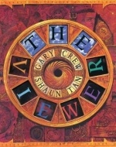
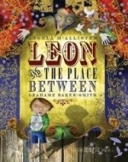
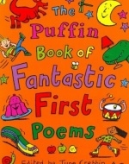
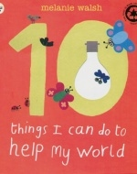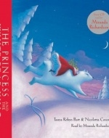

Reading for Pleasure and comfortable places to read
We know that certain elements promote a love of reading, which include freedom to choose a variety of books and quiet comfortable places to read.
How you can help at home?
- The importance of parents and the home environment are essential to the early teaching of reading and for fostering a love of reading. Research repeatedly shows that parental involvement in their child’s reading practices is immensely powerful.
- Reading to your child enriches language development by giving your son or daughter many opportunities to hear stories that they may not yet be able to read for themselves. Making the characters come to life using funny voices (the sillier the better) will make you both laugh!
- Share a story. For a younger child, reading a story that has repeated phrases your child can read to you, encourages an enthusiasm for books.
- Read a play, where you can choose parts, is another favourite.
- Mix it up. Remember picture books, information books, poetry, comics and magazines are all great ways of adding to the reading experience and prevent boredom.
- Take a trip to the library. It costs nothing to register. In fact, you can register as soon as your child is born! Make sure you use it regularly.
- Book Making-make it look realistic, with an ISBN and price tag! Your child will love being an author, especially if they have an audience to read their book to.(use different types of paper, pencils, markers and crayons)
- Let your child see you reading. You’re role model!!
- Be an excited and accepting audience.....
- Encourage your child to write messages, shopping lists, captions for photos, speech bubbles, reminders for you, post-it-notes, thank you cards, get well wishes, labels.... the list is endless.
- Remember that game with folded paper, where each of you writes the next part of the story....?
- Include as many high frequency and sight words as you can, in context. Use every opportunity to write (and read) the words you know your child finds tricky.
Christie Ritman-Meer/Matthew Bailey- English Leaders

